# Inspecting a DataFrame - Column Information

This document includes the question, the solution, and a breakdown of the code provided in the screenshot.

## Uploaded Screenshot

Below is the screenshot of the task:

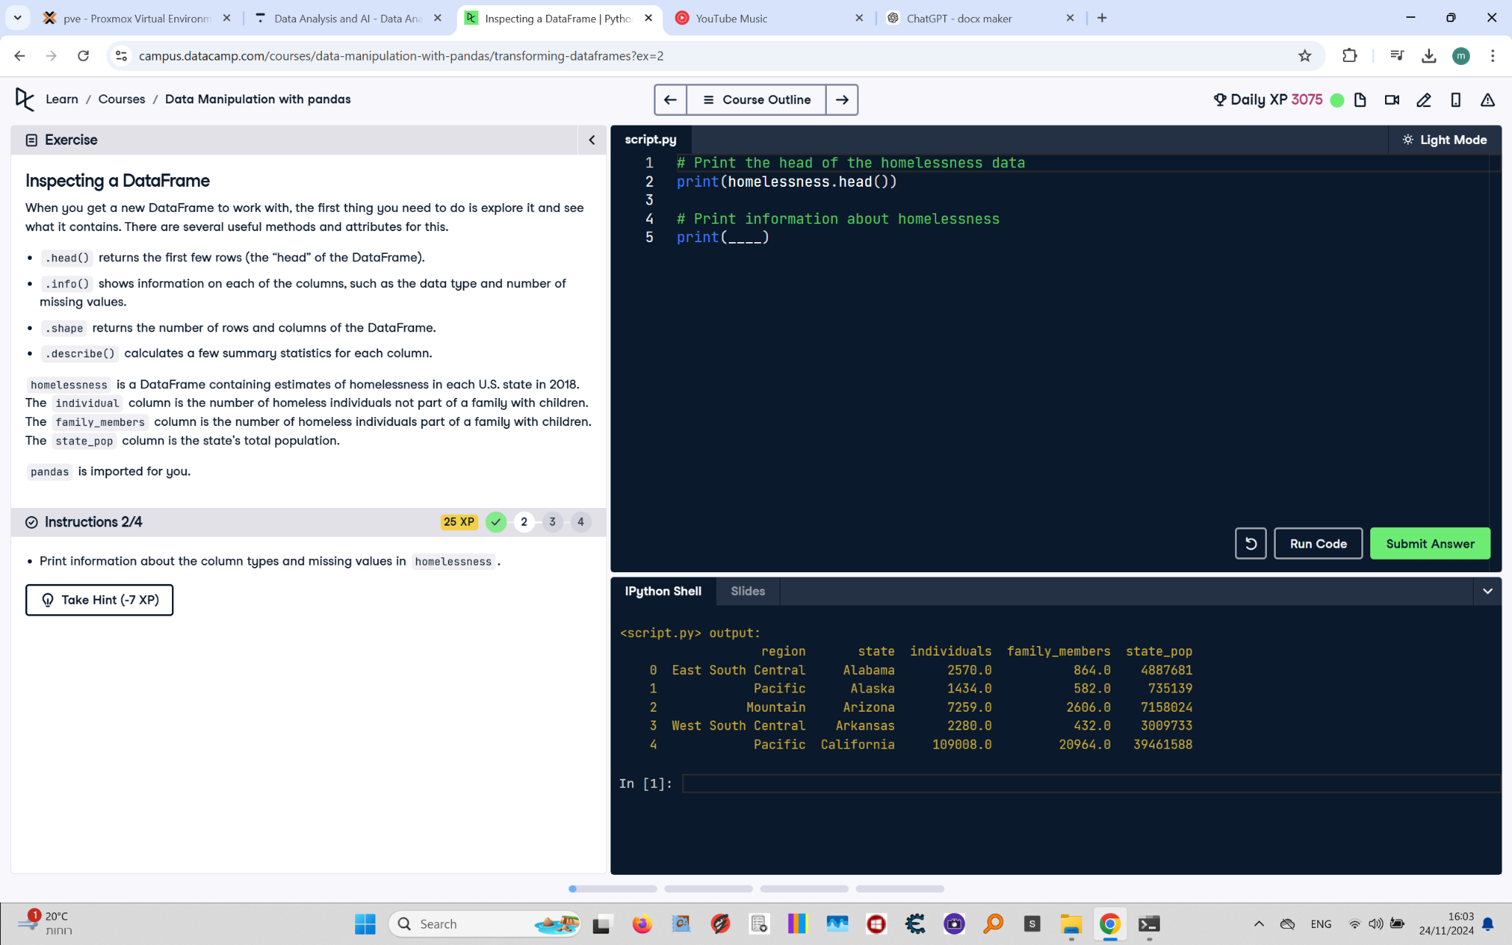

## Question

Print information about the column types and missing values in homelessness.

## Answer

# Print the head of the homelessness data  
print(homelessness.head())  
  
# Print information about homelessness  
print(homelessness.info())

## Code Explanation

# Explanation of the code:

1. `print(homelessness.head())`: This prints the first five rows of the `homelessness` DataFrame for a quick preview.

2. `print(homelessness.info())`: This provides detailed information about the DataFrame, including:

- The data types of each column.

- The number of non-missing (non-null) values in each column.

- The memory usage of the DataFrame.